***Aditya Parashar***

SAP ID:500119510

**AIML WORK**

# **Lab - 1**

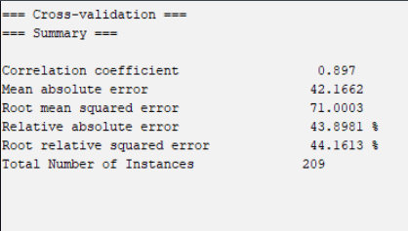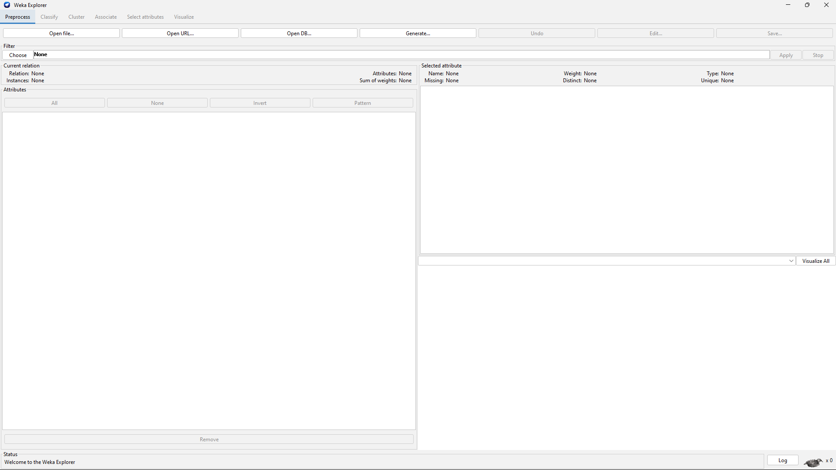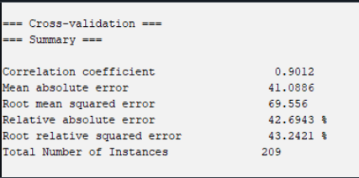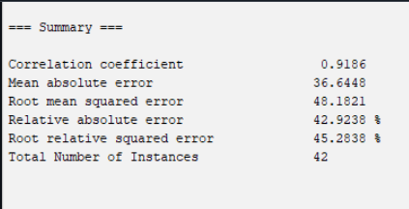

# **Lab – 2**

# **Lab – 3**

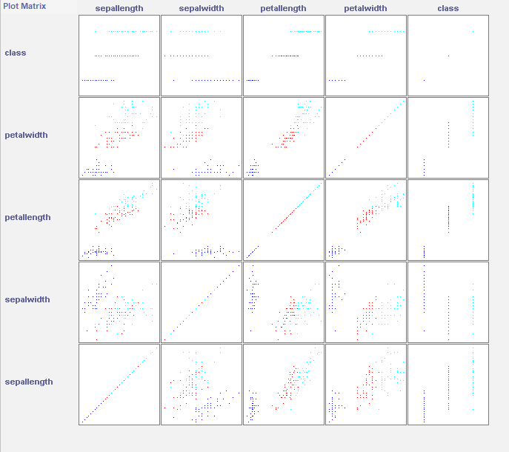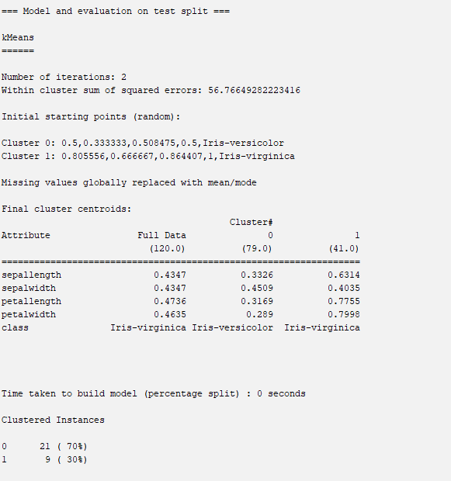

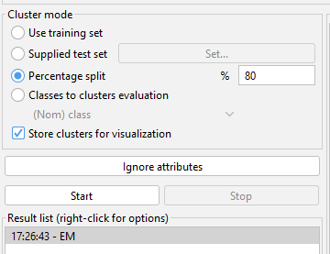

The task of grouping data points based on their similarity with each other is called Clustering or Cluster Analysis.

The various types of clustering are:

* Hierarchical clustering
* Partitioning clustering

Hierarchical clustering is further subdivided into:

* Agglomerative clustering
* Divisive clustering

Partitioning clustering is further subdivided into:

* K-Means clustering
* Fuzzy C-Means clustering

W There is no labeled data for this clustering, unlike in supervised learning. K-Means performs the division of objects into clusters that share similarities and are dissimilar to the objects belonging to another cluster.

## STEPS INVOLVED

dataset used :- *iris.arff*

* NORMALISE THE DATASET
* Go to cluster menu and use percentage split **80%**

# **Lab – 4**

**import** pandas **as** pd

**import** pandas **as** pd  
df1 **=** pd**.**read_csv('Normal-ECG.csv')  
df2 **=** pd**.**read_csv('Dia-ECG.csv')

mean_value **=** df1**.**mean()  
max_value **=** df1**.**max()  
min_value **=** df1**.**min()  
std_dev **=** df1**.**std()  
median_value **=** df1**.**median()

print("Mean value:\n", mean_value)  
print("\nMax value:\n", max_value)  
print("\nMin value:\n", min_value)  
print("\nStandard Deviation:\n", std_dev)  
print("\nMedian value:\n", median_value)

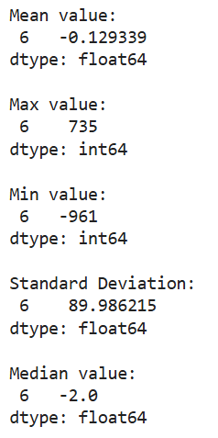

df2**.**replace(['ekg', 'uv'], 0, inplace**=True**)

mean_value **=** df2**.**mean()  
max_value **=** df2**.**max()  
min_value **=** df2**.**min()  
std_dev **=** df2**.**std()  
median_value **=** df2**.**median()

print("Mean value:\n", mean_value)  
print("\nMax value:\n", max_value)  
print("\nMin value:\n", min_value)  
print("\nStandard Deviation:\n", std_dev)  
print("\nMedian value:\n", median_value)

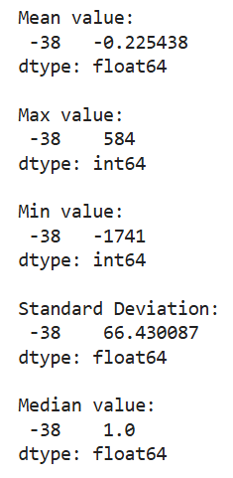

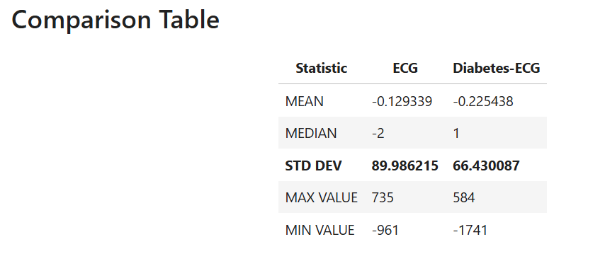

# **Lab – 5**

*# Load libraries*  
**import** pandas **as** pd  
**from** sklearn.tree **import** DecisionTreeClassifier *# Import Decision Tree Classifier*  
**from** sklearn.model_selection **import** train_test_split *# Import train_test_split function*  
**from** sklearn **import** metrics *#Import scikit-learn metrics module for accuracy calculation*

emotions **=** pd**.**read_csv("emotions.csv")

positive **=** emotions[emotions['label'] **==** 'POSITIVE']**.**drop(columns**=**['label'])  
negative **=** emotions[emotions['label'] **==** 'NEGATIVE']**.**drop(columns**=**['label'])  
neutral **=** emotions[emotions['label'] **==** 'NEUTRAL']**.**drop(columns**=**['label'])

*# MEANS*   
avg_positive **=** positive**.**mean()  
print(avg_positive)  
avg_negative **=** negative**.**mean()  
print(avg_negative)  
avg_neutral **=** neutral**.**mean()  
print(avg_neutral)

*# MEDIAN*  
median_positive **=** positive**.**median()  
print(median_positive)  
median_negative **=** negative**.**median()  
print(median_negative)  
median_neutral **=** neutral**.**median()  
print(median_neutral)

*# MODE*  
mode_positive **=** positive**.**mode()  
print(mode_positive)  
mode_negative **=** negative**.**mode()  
print(mode_negative)  
mode_neutral **=** neutral**.**mode()  
print(mode_neutral)

*# MAX*  
max_positive **=** positive**.**max()  
print(max_positive)  
max_negative **=** negative**.**max()  
print(max_negative)  
max_neutral **=** neutral**.**mode()  
print(max_neutral)

*# MIN*  
min_positive **=** positive**.**min()  
print(min_positive)  
min_negative **=** negative**.**min()  
print(min_negative)  
min_neutral **=** neutral**.**min()  
print(min_neutral)

*# STANDARD DEVIATION*  
std_positive **=** positive**.**std()  
print(std_positive)  
std_negative **=** negative**.**std()  
print(std_negative)  
std_neutral **=** neutral**.**std()  
print(std_neutral)

count_positive **=** positive**.**value_counts()  
print(count_positive)  
count_negative **=** negative**.**value_counts()  
print(count_negative)  
count_neutral **=** neutral**.**value_counts()  
print(count_neutral)

# **Lab – 6**

**import** matplotlib.pyplot **as** plt  
**import** numpy **as** np  
**import** pandas **as** pd  
**import** seaborn **as** sns  
  
**from** sklearn **import** datasets  
**from** sklearn.model_selection **import** train_test_split , KFold  
**from** sklearn.preprocessing **import** Normalizer  
**from** sklearn.metrics **import** accuracy_score  
**from** sklearn.neighbors **import** KNeighborsClassifier  
  
**from** collections **import** Counter

iris **=** datasets**.**load_iris()  
*# np.c_ is the numpy concatenate function*  
iris_df **=** pd**.**DataFrame(data**=** np**.**c_[iris['data'], iris['target']],  
 columns**=** iris['feature_names'] **+** ['target'])  
iris_df**.**head()

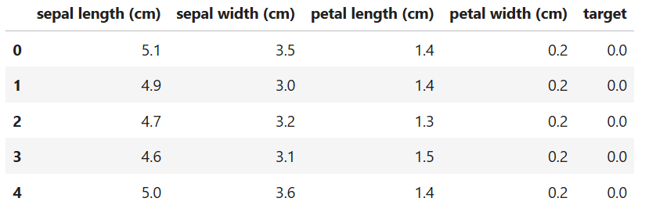iris**.**feature_names  
iris**.**target_names

iris_df**.**describe()

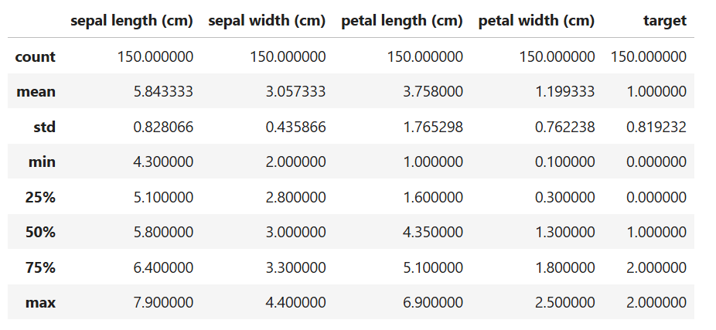x**=** iris_df**.**iloc[:, :**-**1]  
y**=** iris_df**.**iloc[:, **-**1]

x**.**head()

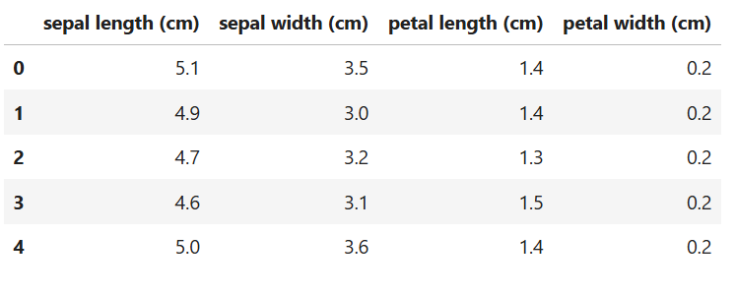y**.**head()

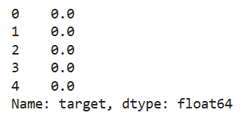

iris_df[iris_df**.**target **==**1]**.**head  
iris_df[iris_df**.**target **==**2]**.**head

x_train, x_test, y_train, y_test**=** train_test_split(x, y,  
 test_size**=** 0.2,  
 shuffle**=** **True**,  
 random_state**=** 0)  
x_train**=** np**.**asarray(x_train)  
y_train**=** np**.**asarray(y_train)  
x_test**=** np**.**asarray(x_test)  
y_test**=** np**.**asarray(y_test)

print(f'training set size: {x_train**.**shape[0]} samples \ntest set size: {x_test**.**shape[0]} samples')



scaler**=** Normalizer()**.**fit(x_train)  
normalized_x_train**=** scaler**.**transform(x_train)  
normalized_x_test**=** scaler**.**transform(x_test)

print('x train before Normalization')  
print(x_train[0:5])  
print('\nx train after Normalization')  
print(normalized_x_train[0:5])

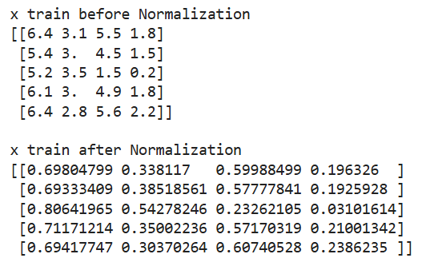

*## Before*  
*# View the relationships between variables; color code by species type*  
di**=** {0.0: 'Setosa', 1.0: 'Versicolor', 2.0:'Virginica'} *# dictionary*  
  
*before***=** sns**.**pairplot(iris_df**.**replace({'target': di}), hue**=** 'target')  
before**.**fig**.**suptitle('Pair Plot of the dataset Before normalization', y**=**1.08)  
  
*## After*  
iris_df_2**=** pd**.**DataFrame(data**=** np**.**c_[normalized_x_train, y_train],  
 columns**=** iris['feature_names'] **+** ['target'])  
di**=** {0.0: 'Setosa', 1.0: 'Versicolor', 2.0: 'Virginica'}  
after**=** sns**.**pairplot(iris_df_2**.**replace({'target':di}), hue**=** 'target')  
after**.**fig**.**suptitle('Pair Plot of the dataset After normalization', y**=**1.08)

**def** distance_ecu(x_train, x_test_point):  
 """  
 Input:  
 - x_train: corresponding to the training data  
 - x_test_point: corresponding to the test point  
  
 Output:  
 -distances: The distances between the test point and each point in the training data.  
  
 """  
 distances**=** [] *## create empty list called distances*  
 **for** row **in** range(len(x_train)): *## Loop over the rows of x_train*  
 current_train_point**=** x_train[row] *#Get them point by point*  
 current_distance**=** 0 *## initialize the distance by zero*  
  
 **for** col **in** range(len(current_train_point)): *## Loop over the columns of the row*  
   
 current_distance **+=** (current_train_point[col] **-** x_test_point[col]) **\*\***2  
 *## Or current_distance = current_distance + (x_train[i] - x_test_point[i])**2*  
 current_distance**=** np**.**sqrt(current_distance)  
  
 distances**.**append(current_distance) *## Append the distances*  
  
 *# Store distances in a dataframe*  
 distances**=** pd**.**DataFrame(data**=**distances,columns**=**['dist'])  
 **return** distances

In [46]:

**def** nearest_neighbors(distance_point, K):  
 """  
 Input:  
 -distance_point: the distances between the test point and each point in the training data.  
 -K : the number of neighbors  
  
 Output:  
 -df_nearest: the nearest K neighbors between the test point and the training data.  
  
 """  
  
 *# Sort values using the sort_values function*  
 df_nearest**=** distance_point**.**sort_values(by**=**['dist'], axis**=**0)  
  
 *## Take only the first K neighbors*  
 df_nearest**=** df_nearest[:K]  
 **return** df_nearest

In [47]:

**def** voting(df_nearest, y_train):  
 """  
 Input:  
 -df_nearest: dataframe contains the nearest K neighbors between the full training dataset and the test point.  
 -y_train: the labels of the training dataset.  
  
 Output:  
 -y_pred: the prediction based on Majority Voting  
  
 """  
  
 *## Use the Counter Object to get the labels with K nearest neighbors.*  
 counter_vote**=** Counter(y_train[df_nearest**.**index])  
  
 y_pred**=** counter_vote**.**most_common()[0][0] *# Majority Voting*  
  
 **return** y_pred

In [48]:

**def** KNN_from_scratch(x_train, y_train, x_test, K):  
  
 """  
 Input:  
 -x_train: the full training dataset  
 -y_train: the labels of the training dataset  
 -x_test: the full test dataset  
 -K: the number of neighbors  
  
 Output:  
 -y_pred: the prediction for the whole test set based on Majority Voting.  
  
 """  
  
 y_pred**=**[]  
  
 *## Loop over all the test set and perform the three steps*  
 **for** x_test_point **in** x_test:  
 distance_point **=** distance_ecu(x_train, x_test_point) *## Step 1*  
 df_nearest_point**=** nearest_neighbors(distance_point, K) *## Step 2*  
 y_pred_point **=** voting(df_nearest_point, y_train) *## Step 3*  
 y_pred**.**append(y_pred_point)  
  
 **return** y_pred

In [49]:

K**=**3  
y_pred_scratch**=** KNN_from_scratch(normalized_x_train, y_train, normalized_x_test, K)  
print(y_pred_scratch)

knn**=**KNeighborsClassifier(K)  
knn**.**fit(normalized_x_train, y_train)  
y_pred_sklearn**=** knn**.**predict(normalized_x_test)  
print(y_pred_sklearn)

print(np**.**array_equal(y_pred_sklearn, y_pred_scratch))

print(f'The accuracy of our implementation is {accuracy_score(y_test, y_pred_scratch)}')  
print(f'The accuracy of sklearn implementation is {accuracy_score(y_test, y_pred_sklearn)}')

n_splits**=** 4 *## Choose the number of splits*  
kf**=** KFold(n_splits**=** n_splits) *## Call the K Fold function*  
  
*accuracy_k***=** [] *## Keep track of the accuracy for each K*  
k_values**=** list(range(1,30,2)) *## Search for the best value of K*  
  
**for** k **in** k_values: *## Loop over the K values*  
 accuracy_fold**=** 0  
 **for** normalized_x_train_fold_idx, normalized_x_valid_fold_idx **in** kf**.**split(normalized_x_train): *## Loop over the splits*  
 normalized_x_train_fold**=** normalized_x_train[normalized_x_train_fold_idx] *## fetch the values*  
 y_train_fold**=** y_train[normalized_x_train_fold_idx]  
  
 normalized_x_test_fold**=** normalized_x_train[normalized_x_valid_fold_idx]  
 y_valid_fold**=** y_train[normalized_x_valid_fold_idx]  
 y_pred_fold**=** KNN_from_scratch(normalized_x_train_fold, y_train_fold, normalized_x_test_fold, k)  
  
 accuracy_fold**+=** accuracy_score (y_pred_fold, y_valid_fold) *## Accumulate the accuracy*  
 accuracy_fold**=** accuracy_fold**/** n_splits *## Divide by the number of splits*  
 accuracy_k**.**append(accuracy_fold)

print(f'The accuracy for each K value was {list ( zip (accuracy_k, k_values))}') *## creates a tuple with accuracy corresponding to k value*

print(f'Best accuracy was {np**.**max(accuracy_k)}, which corresponds to a value of K= {k_values[np**.**argmax(accuracy_k)]}')

k_values **=** [1, 3, 5, 7, 9]  
  
results **=** {}  
  
**for** k **in** k_values:  
 knn **=** KNeighborsClassifier(n_neighbors**=**k)  
   
 knn**.**fit(x_train, y_train)  
   
 y_pred **=** knn**.**predict(x_test)  
 accuracy **=** accuracy_score(y_test, y_pred)  
   
 results[k] **=** accuracy  
 print(f'k={k}, Accuracy={accuracy:.4f}')

# **Lab – 7**

**import** numpy **as** np  
**import** pandas **as** pd  
**from** sklearn.preprocessing **import** OneHotEncoder  
**from** sklearn **import** datasets  
  
iris **=** datasets**.**load_iris()

df **=** pd**.**DataFrame(iris**.**data, columns**=**iris**.**feature_names)  
df**.**head()

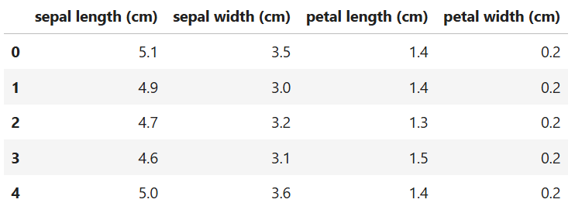df**.**tail()

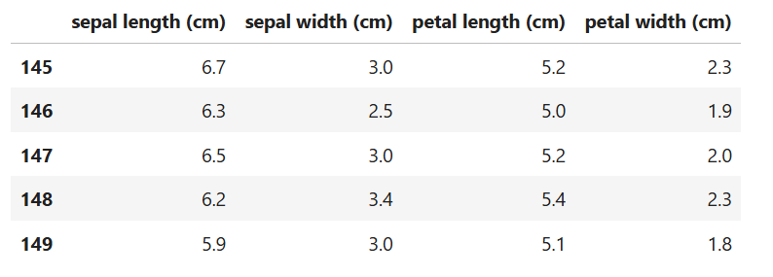

Df**.**dtypes

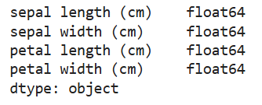

encoder **=** OneHotEncoder()

iris_data **=** iris['data']  
iris_target **=** iris['target']  
  
df['target'] **=** iris**.**target  
df**.**head()

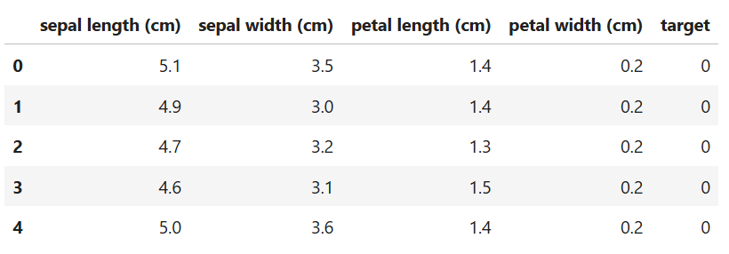df['flower_name'] **=** df**.**target**.**apply(**lambda** x : iris**.**target_names[x])  
df**.**head()

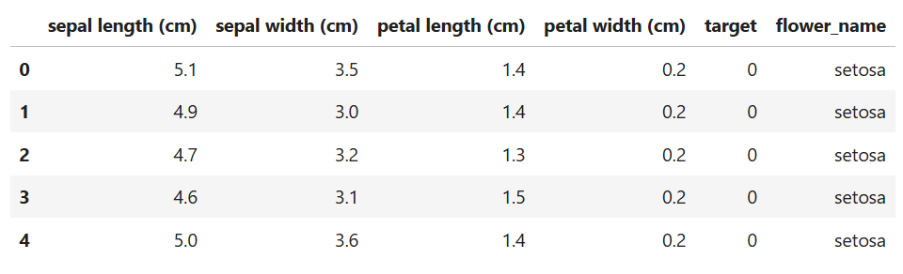print(df["flower_name"])

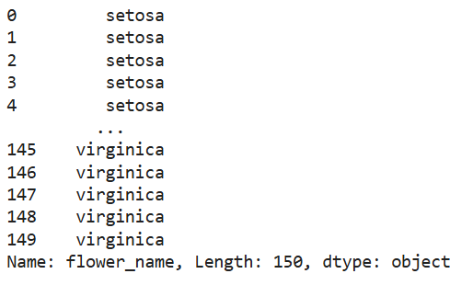

feature_arr **=** encoder**.**fit_transform(df[["flower_name"]])**.**toarray()

feature_arr

feature_labels **=** encoder**.**categories_

feature_labels **=** np**.**array(feature_labels)**.**ravel()

pd**.**DataFrame(feature_arr, columns**=**feature_labels)

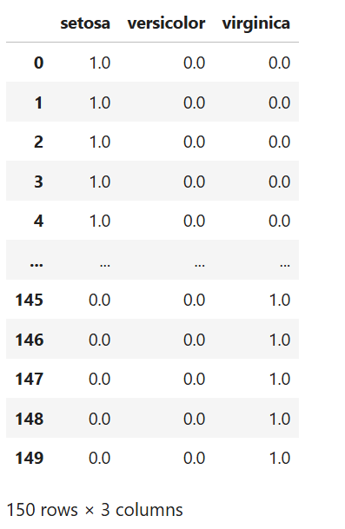

**import** pandas **as** pd  
**from** sklearn.preprocessing **import** OneHotEncoder  
**import** numpy **as** np

df **=** pd**.**read_csv("data.csv")

print(df**.**head())  
print(df**.**tail())

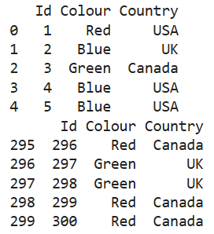

Df**.**dtypes

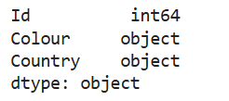

print(df['Country']**.**unique())  
print(df['Colour']**.**unique())

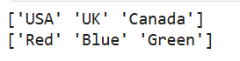

print(df['Country']**.**value_counts())  
print(df['Colour']**.**value_counts())

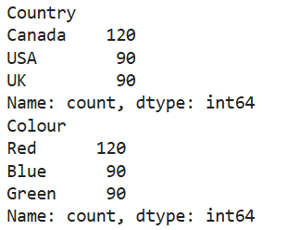

ohe **=** OneHotEncoder()

print(ohe**.**fit_transform(df[["Colour" , "Country"]])**.**toarray)  
print(ohe**.**fit_transform(df[["Colour" , "Country"]])**.**toarray())

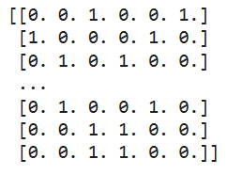

feature_array **=** ohe**.**fit_transform(df[["Colour" , "Country"]])**.**toarray()

ohe**.**categories_  
feature_labels **=** ohe**.**categories_

feature_labels **=** np**.**array(feature_labels)**.**ravel()

feature_array

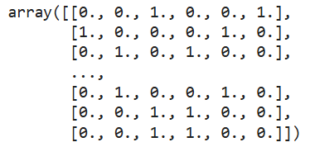

feature_labels

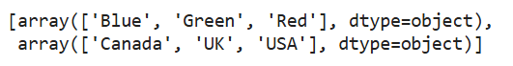

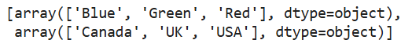

pd**.**DataFrame(feature_array, columns**=**feature_labels)

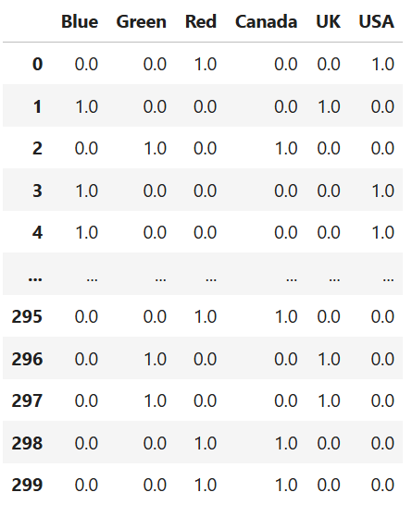

# **Lab – 8**

**import** numpy **as** np  
**import** pandas **as** pd  
**from** sklearn.decomposition **import** PCA  
**from** sklearn.datasets **import** load_iris  
**from** sklearn.preprocessing **import** StandardScaler  
**import** matplotlib.pyplot **as** plt

iris **=** load_iris()

scaler **=** StandardScaler()  
iris_scaled **=** scaler**.**fit_transform(iris**.**data)

X **=** iris**.**data *# Features*  
y **=** iris**.**target *#species*  
feature_names **=** iris**.**feature_names

print("Mean of features after scaling:", np**.**mean(iris_scaled, axis**=**0))  
print("Standard deviation of features after scaling:", np**.**std(iris_scaled, axis**=**0))

pca **=** PCA(n_components**=**2)  
iris_pca **=** pca**.**fit_transform(iris_scaled)

pca **=** PCA(n_components**=**2)  
iris_pca **=** pca**.**fit_transform(iris_scaled)

pca_df **=** pd**.**DataFrame(data**=**iris_pca, columns**=**['PC1', 'PC2'])  
pca_df['species'] **=** pd**.**Categorical**.**from_codes(y, iris**.**target_names)

pca_df

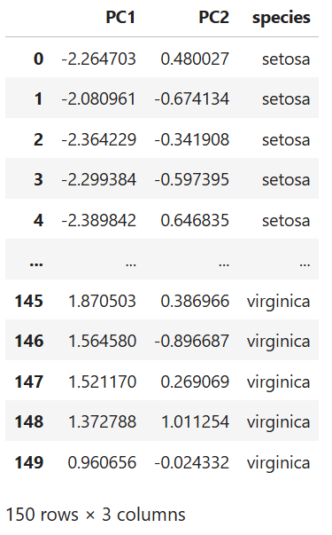

plt**.**figure(figsize**=**(8, 6))  
**for** species **in** iris**.**target_names:  
 species_data **=** pca_df[pca_df['species'] **==** species]  
 plt**.**scatter(species_data['PC1'], species_data['PC2'], label**=**species)  
  
plt**.**xlabel('Principal Component 1')  
plt**.**ylabel('Principal Component 2')  
plt**.**title('PCA of Iris Dataset')  
plt**.**legend()  
plt**.**show()

